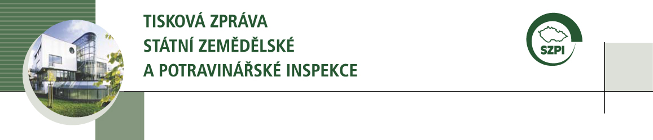

Consumers’ suggestions for inspections in year 2012

From the beginning of this year, the Czech Agriculture and Food Inspection Authority (CAFIA) registers an enormous increase of consumers’ suggestions. From January to February 2012, the number of delivered submissions increases two-and-half times.

CAFIA checks all the submissions, which are specific enough to carry out an inspection.

Consumers’ suggestions represent important source of impulses for CAFIA inspection activity and also serve as one of the indicators during the assessment of risk analysis of particular commodities and food premises.

Current data about the suggestions which were submitted to CAFIA from 1/1/2012 to 2/29/2012:

Inspectorate CAFIA | Number of suggestions  1/1/2012-2/29/2012
Headquarters | 115
Ústí nad Labem | 65
Brno | 106
Plzeň | 59
Praha | 213
Tábor | 54
Hradec Králové | 58
Olomouc | 41
In total | 711

Article by: Michal Spáčil, CAFIA spokesperson
2/29/2012

